Name : Shubham Kure Roll no: 220

Experiment no7: Display servertime using digital clock.
Code:
<!DOCTYPE html>
<html>
<head>
<title>Digital Clock</title>
<style> body { font-family: Arial, sans-serif; background: #000; color: #0f0; text-align: center; font-size: 48px; margin-top: 20%;
}
</style>
</head>
<body>

<?php
// Get the current server time date_default_timezone_set('UTC'); // Change to your timezone if needed
$serverTime = date("H:i:s");
?>

<div id="clock"><?php echo $serverTime; ?></div>
<script> function updateClock() { const clock = document.getElementById('clock'); let time = new Date();
clock.innerHTML = time.toLocaleTimeString();
}
setInterval(updateClock, 1000);
</script>

</body>
</html>

Output:
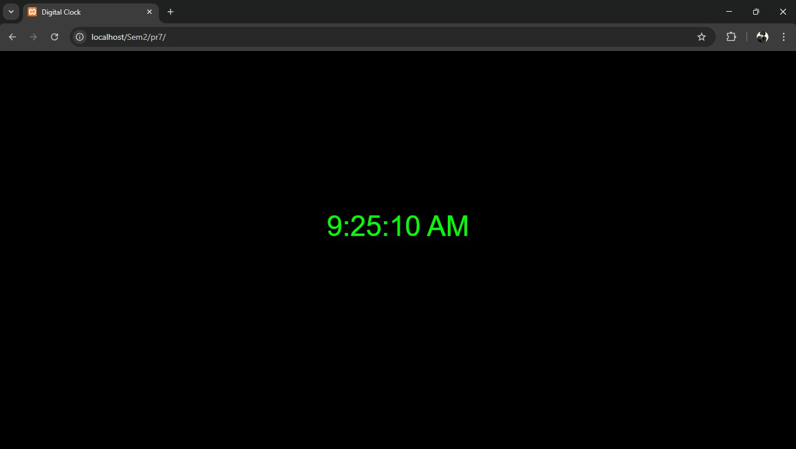

Name :Sarvesh Padole Roll no: 233

Experiment no8: Write a PHP program to implement sign-In and Sign-out functionality.
Login.php
<?php
session_start();

// Dummy credentials
$valid_username = 'admin';
$valid_password = '12345';

// Handle form submission if ($_SERVER['REQUEST_METHOD'] === 'POST') { $username = $_POST['username'] ?? '';
$password = $_POST['password'] ?? '';
if ($username === $valid_username && $password === $valid_password) {
$_SESSION['user'] = $username; header('Location: welcome.php'); exit;
} else {
$error = "Invalid username or password!";
}
}
?>

<!DOCTYPE html>
<html>
<head>
<title>Sign-In</title>
</head>

<body>
<h2>Login</h2>
<?php if (!empty($error)) echo "<p style='color:red;'>$error</p>"; ?>
<form method="post" action="login.php">
Username: <input type="text" name="username" required><br><br>
Password: <input type="password" name="password" required><br><br>
<button type="submit">Sign In</button>
</form>
</body>
</html>
Welcome.php
<?php session_start(); if (!isset($_SESSION['user'])) { header('Location: login.php'); exit;
}
?>

<!DOCTYPE html>
<html>
<head>
<title>Welcome</title>
</head>

<body>
<h2>Welcome, <?php echo htmlspecialchars($_SESSION['user']); ?>!</h2>
<p><a href="logout.php">Sign Out</a></p>
</body>
</html>
Logout.php
<?php session_start(); session_unset(); session_destroy(); header('Location: login.php'); exit;

Output:
